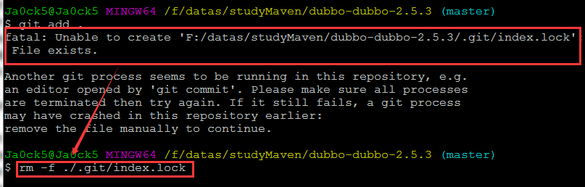

$ git add .

fatal: Unable to create 'F:/datas/studyMaven/dubbo-dubbo-2.5.3/.git/index.lock': File exists.

Another git process seems to be running in this repository, e.g.

an editor opened by 'git commit'. Please make sure all processes

are terminated then try again. If it still fails, a git process

may have crashed in this repository earlier:

remove the file manually to continue.

解决方法：

rm -f ./.git/index.lock